LG Iron
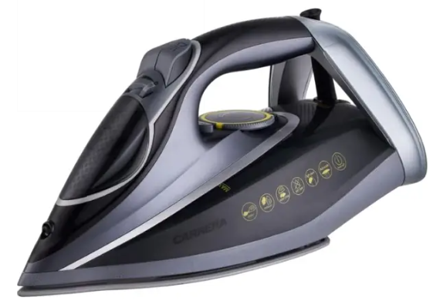
Rs.12,184
An LG electric iron is designed for efficient wrinkle removal with modern steam technology, offering smooth gliding, quick heating, and safety features for everyday ironing.

Specifications
- Power: ~1200W – 1800W
- Water Tank Capacity: ~150 – 300 ml
- Voltage: 220–240V
- Heating Time: ~20–30 seconds (fast start models)

Key Features
- Modern Steam Technology
- Adjustable Temperature Control
- Anti-Calc System
- Ceramic / Non-stick Soleplate

